From El Paso Times
Author of Disney's 'Coco' book adaptation speaks at El Paso schools
Author Diana Lopez, who wrote the book adaptation of the Disney-Pixar film 'Coco,' spoke at El Paso schools and will host a Q&A at Alamo Drafthouse.
https://www.elpasotimes.com/story/news/2019/01/10/coco-adaptation-author-speaks-el-paso-schools-promote-reading-alamo-drafthouse/2528592002/

Author of Disney's 'Coco' book adaptation speaks at El Paso schools
El Paso Times Published 7:00 a.m. MT Jan. 10, 2019

Author of Disney's 'Coco' book adaptation speaks at El Paso schools
Author Diana Lopez, who wrote the book adaptation of the Disney-Pixar film 'Coco,' spoke at El Paso schools and will host a Q&A at Alamo Drafthouse.

CancelSend

Sent!
A link has been sent to your friend's email address.

Join the Conversation
To find out more about Facebook commenting please read the Conversation Guidelines and FAQs
This conversation is moderated according to USA TODAY's community rules. Please read the rules before joining the discussion.

Author of Disney's 'Coco' book adaptation speaks at El Paso schools
El Paso Times Published 7:00 a.m. MT Jan. 10, 2019
FacebookTwitterGoogle+LinkedIn
Coco Author Speaks at Area El Paso Schools
Fullscreen
Diana Lopez who wrote the book adaptation of Coco is visiting area schools on behalf of the anti-bullying organization Lucid Love. Lopez spoke on not giving up after you've heard "no" several times. Lopez used several examples of successful hispanics in America to deliver her message of perseverance. Mark Lambie / El Paso Times

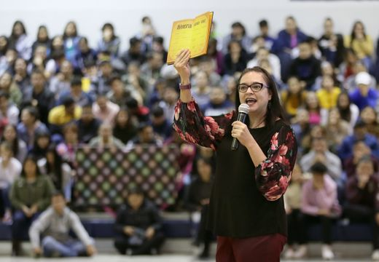
Buy Photo
Diana Lopez who wrote the book adaptation of Coco is visiting area schools on behalf of the anti-bullying organization Lucid Love. Lopez spoke on not giving up after you've heard "no" several times. Lopez used several examples of successful hispanics in America to deliver her message of perseverance. Mark Lambie / El Paso Times
Buy Photo
Fullscreen
10 Photos
Coco Author Speaks at Area El Paso Schools

Buy Photo
Diana Lopez who wrote the book adaptation of Coco is visiting area schools on behalf of the anti-bullying organization Lucid Love. Lopez spoke on not giving up after you've heard "no" several times. Lopez used several examples of successful hispanics in America to deliver her message of perseverance. Mark Lambie / El Paso Times
Buy Photo
Fullscreen

Buy Photo
Diana Lopez who wrote the book adaptation of Coco is visiting area schools on behalf of the anti-bullying organization Lucid Love. Lopez spoke on not giving up after you've heard "no" several times. Lopez used several examples of successful hispanics in America to deliver her message of perseverance. Mark Lambie / El Paso Times
Buy Photo
Fullscreen

Buy Photo
Diana Lopez who wrote the book adaptation of Coco is visiting area schools on behalf of the anti-bullying organization Lucid Love. Lopez spoke on not giving up after you've heard "no" several times. Lopez used several examples of successful hispanics in America to deliver her message of perseverance. Mark Lambie / El Paso Times
Buy Photo
Fullscreen

Buy Photo
Diana Lopez who wrote the book adaptation of Coco is visiting area schools on behalf of the anti-bullying organization Lucid Love. Lopez spoke on not giving up after you've heard "no" several times. Lopez used several examples of successful hispanics in America to deliver her message of perseverance. Mark Lambie / El Paso Times
Buy Photo
Fullscreen

Buy Photo
Diana Lopez who wrote the book adaptation of Coco is visiting area schools on behalf of the anti-bullying organization Lucid Love. Lopez spoke on not giving up after you've heard "no" several times. Lopez used several examples of successful hispanics in America to deliver her message of perseverance. Mark Lambie / El Paso Times
Buy Photo
Fullscreen

Buy Photo
Diana Lopez who wrote the book adaptation of Coco is visiting area schools on behalf of the anti-bullying organization Lucid Love. Lopez spoke on not giving up after you've heard "no" several times. Lopez used several examples of successful hispanics in America to deliver her message of perseverance. Mark Lambie / El Paso Times
Buy Photo
Fullscreen

Buy Photo
Diana Lopez who wrote the book adaptation of Coco is visiting area schools on behalf of the anti-bullying organization Lucid Love. Lopez spoke on not giving up after you've heard "no" several times. Lopez used several examples of successful hispanics in America to deliver her message of perseverance. Mark Lambie / El Paso Times
Buy Photo
Fullscreen

Buy Photo
Diana Lopez who wrote the book adaptation of Coco is visiting area schools on behalf of the anti-bullying organization Lucid Love. Lopez spoke on not giving up after you've heard "no" several times. Lopez used several examples of successful hispanics in America to deliver her message of perseverance. Mark Lambie / El Paso Times
Buy Photo
Fullscreen

Buy Photo
Diana Lopez who wrote the book adaptation of Coco is visiting area schools on behalf of the anti-bullying organization Lucid Love. Lopez spoke on not giving up after you've heard "no" several times. Lopez used several examples of successful hispanics in America to deliver her message of perseverance. Mark Lambie / El Paso Times
Buy Photo
Fullscreen

Interested in this topic? You may also want to view these photo galleries:
Replay

1 of 10

- 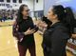2 of 10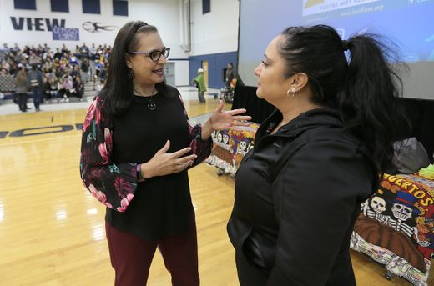

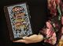3 of 10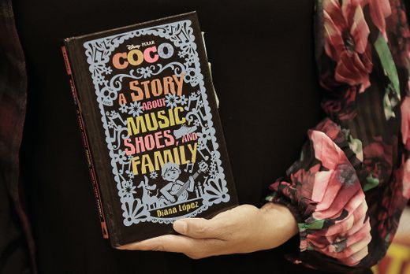

4 of 10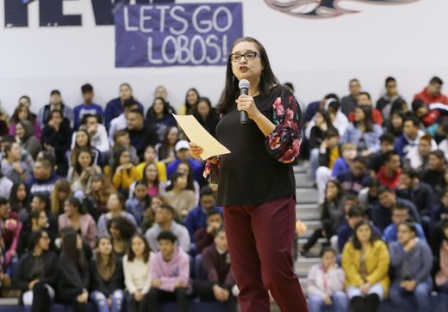

5 of 10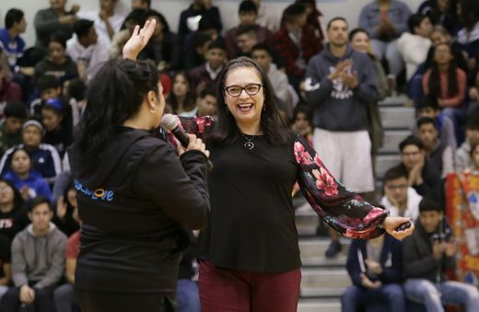

6 of 10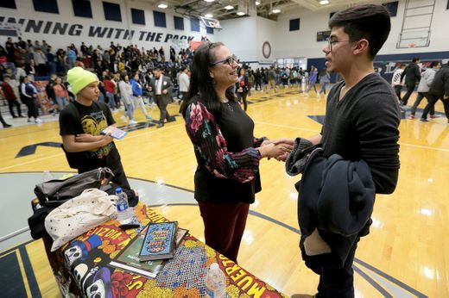

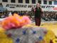7 of 10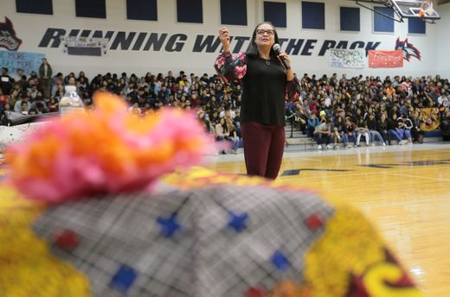

8 of 10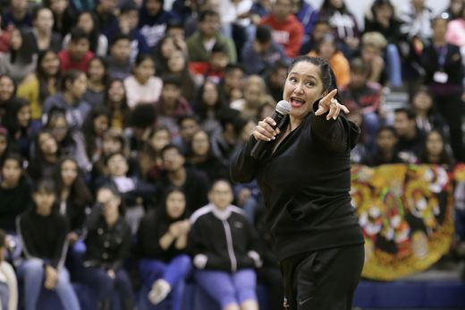

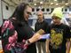9 of 10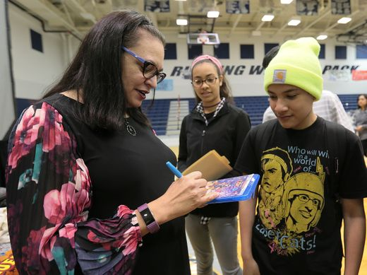

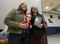10 of 10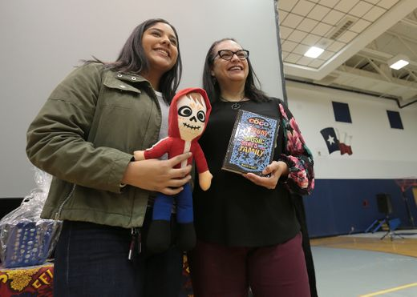

1 of 10
Autoplay
Show Thumbnails
Show Captions
Last SlideNext Slide
CONNECTTWEETLINKEDINCOMMENTEMAILMORE
Coco Author Speaks at Area El Paso Schools
Fullscreen
Diana Lopez who wrote the book adaptation of Coco is visiting area schools on behalf of the anti-bullying organization Lucid Love. Lopez spoke on not giving up after you've heard "no" several times. Lopez used several examples of successful hispanics in America to deliver her message of perseverance. Mark Lambie / El Paso Times

Diana Lopez, who wrote the book adaptation of the Disney-Pixar film "Coco," visited El Paso schools to promote reading and talk about her writing. She will also take part in a Q&A before a screening of the film Friday at Alamo Drafthouse.
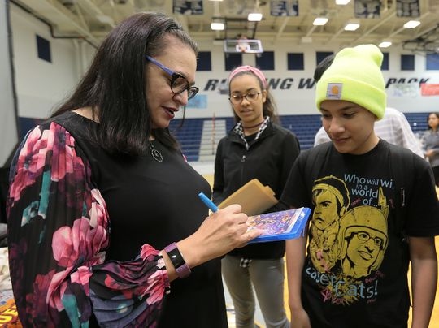Buy Photo
Diana Lopez who wrote the book adaptation of Coco is visiting area schools on behalf of the anti-bullying organization Lucid Love. Lopez spoke on not giving up after you've heard "no" several times. Lopez used several examples of successful hispanics in America to deliver her message of perseverance. (Photo: Mark Lambie / El Paso Times)
Lopez is a former middle school teacher and wrote several teen books. She said in a previous interview that she was drawn to the story because of its positive message.
"What appealed to me most about the story is that it's about a family and you see these characters are connected across generations," she said. "And when you say family, it's not just immediate family, but cousins, aunts and uncles and grandparents."
More: Author of 'Coco' book adaptation to visit at Alamo Drafthouse, El Paso, Clint schools

Read or Share this story: https://www.elpasotimes.com/story/news/2019/01/10/coco-adaptation-author-speaks-el-paso-schools-promote-reading-alamo-drafthouse/2528592002/

2nd write-up

From El Paso Times
Author of 'Coco' book adaptation to visit at Alamo Drafthouse, El Paso, Clint schools
Texan author of 'Coco' book adaptation Diana Lopez to visit at Alamo Drafthouse, El Paso, Clint schools in January
https://www.elpasotimes.com/story/entertainment/2018/12/26/disney-coco-author-visit-alamo-drafthouse-el-paso-clint-schools/2225988002/

Author of 'Coco' book adaptation to visit at Alamo Drafthouse, El Paso, Clint schools
María Cortés González, El Paso Times Published 6:00 p.m. MT Dec. 26, 2018 | Updated 11:39 a.m. MT Jan. 3, 2019
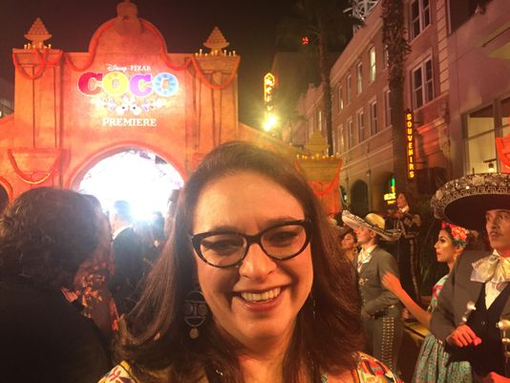
Author Diana Lopez will be in El Paso to share her writing experiences. She wrote the story "Coco," based on the movie screenplay.(Photo: COURTESY OF DIANA LOPEZ)
CONNECTTWEETLINKEDINCOMMENTEMAILMORE
You could say Texan author Diana Lopez's first book, "Confetti Girl" led to the opportunity to write the book adaptation of the popular Disney movie, "Coco."
An editor in charge of assigning the story thought of Lopez years after she had read the author's 2009 middle-school book in a college class.
"Adrian Molina had written the screenplay for the movie that we all love and enjoyed. And they reached out to me. They wanted me to take the screenplay and expand the story and add scenes," she said.
Lopez, who had honed her skills writing several teen books, was excited about the project. She will promote reading and talk about her writing during several stops in Ysleta and Clint schools Jan. 8-11. She also will participate in a Q&A before a screening of the film Jan. 11 at the Alamo Drafthouse.
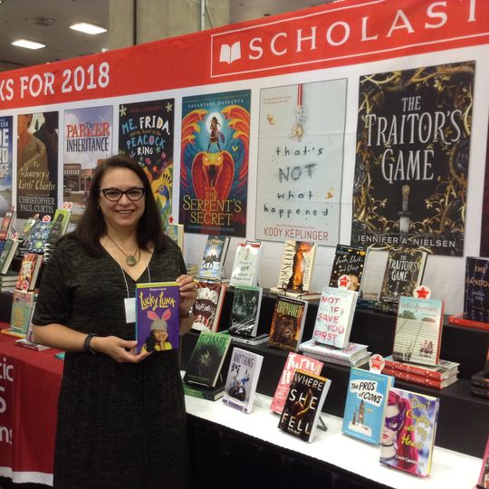
Author Diana Lopez, who wrote the story "Coco," based on the movie screenplay, has written several books for young readers. (Photo: COURTESY OF DIANA LOPEZ)
A former middle school teacher for 10 years, Lopez said her experience with tweens gave her a good sense of their voice and interests.
"I started writing for children because it came more naturally to me (than writing adult novels)," she said. "I love writing for young people because they are very interesting in the sense that they are waking up to things in the world cognitively but emotionally they are still children. They feel so intensely."
Surrounded by her culture, Lopez said she never had to look elsewhere for inspiration for her characters.
By the time, the opportunity for the "Coco" book came about, Lopez had already published six middle school novels. She recently published another book titled, "Lucky Luna" that takes place in her hometown of Corpus Christi.
Lopez said she was impressed with the film production and its efforts to remain authentic to the Hispanic culture.
"What appealed to me most about the story is that it's about a family and you see these characters are connected across generations," she said. "And when you say family, it's not just immediate family, but cousins, aunts and uncles and grandparents."
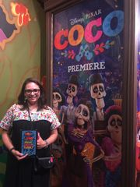
Author Diana Lopez, who wrote the story "Coco," based on the movie screenplay got to attend the premiere. (Photo: COURTESY OF DIANA LOPEZ)
When it came to write the book, Lopez said she was given creative freedom but she also had to run things by Disney as she went along.
She chose to tell more about Mama Coco, so readers could meet her as a younger woman and see what her life might have been like.
"I also wrote more scenes with the ancestors and the Land of the Dead. I had so much fun with the twin uncles and giving them dialogue in the book. They don't get to say too much in the movie," she said.
Lopez said the twin uncles come to life as two close brothers, who finish each other sentences and like to argue — often with the same point of view.
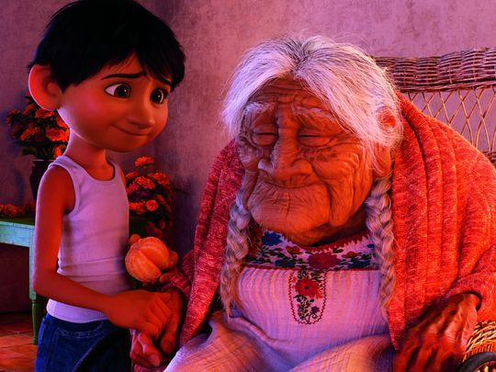
In the film "Coco," Miguel has a special relation with his great grandmother. (Photo: Pixar)
Lopez said she wrote the book while the movie was in still in conceptual form.
"Disney would send me pictures of the concept art with a nondisclosure (agreement) and water marks with my name," she said. "There was a lot of suspense ... I didn't actually get to hear the songs until I got to see the movie."
The book was published about a month before the film was released. Lopez got to see the premiere at the Capitan Theatre in Hollywood. It was a highlight of her writing career.
"I'll never forget it. They know how to throw a premiere. The whole block was closed down and there was a marigold carpet instead of a red carpet," she said. "I got to see Benjamin Bratt, who is the voice of Ernesto de la Cruz, and Gael Garcia Bernal. And then later I got to meet the screenwriter."
Writing a story for the Disney film does not mean Lopez can quit her day job anytime soon. She is a creative writing professor at the University of Houston-Victoria.
But she says the book did change her life a bit.
"What "Coco" did for me was that it actually gave me more presence in the public mind," she said. "It's like people that had never heard of me all of sudden wanted to know what else I had done and who I am."
More: "Coco" actor and El Pasoan Lombardo Boyar
More: Disney Pixar's 'Coco' captures love and closeness of Mexican families
María Cortés González may be reached at 546-6150; mcortes@elpasotimes.com; @EPTMaria on Twitter. Want more feature profiles like this? Click here to subscribe to elpasotimes.com
What: Screening of "Coco"
Who: Q&A with book author Diana Lopez
When: 7 p.m. Jan. 11; book signing in lobby at 6 p.m.
Where: Alamo Drafthouse, 250 E Montecillo Blvd.
Details: The Lucid Love organization will have entertainment, such as mariachis and folklorico, and face painting for families starting at 6 p.m.
Cost: $10 for movie.

