More
Facebook © 2019https://www.facebook.com/events/380688439365946/?ti=ia

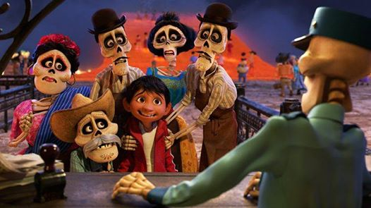

JAN11

Coco with Author Diana Lopez
Public
· Hosted by Alamo Drafthouse El Paso
Interested

clock | Friday, January 11, 2019 at 6:00 PM – 10:00 PM MST  2 days ago

pin | Alamo Drafthouse El Paso  250 East Montecillo Blvd., El Paso, Texas 79912

75 Went · 985 Interested
Share this event with your friends
Details
In partnership with the local non-profit, Lucid Love, we will be celebrating Ms. Lopez's visit to El Paso with a BIG FIESTA!
Join us for a special screening of COCO with a reading by the author of the book adaptation, Diana Lopez.
Barnes and Noble will have copies of the book available for purchase on-site and Ms. Lopez will be signing them in the lobby. Come dressed up and enjoy the entertainment in the Glass Half Full Taproom throughout the evening. Be sure to stick around for a local talent show everyone in the land of the dead would be proud of! We're also bringing back a special COCO themed menu featuring aguas frescas, corn meal cookies, and other muy delicioso treats!
Please see the full schedule below.
COCO screening* with Author Diana Lopez in Theater 7 at 7 PM
*Ticket purchase required for screening.
ALL other events are free to attend and ALL ages are welcome!
In the lobby:
6-7 PM
Face Painting
6-10 PM
Barnes and Noble COCO book sales and signing
COCO inspired photo backdrop
Lucid Love information booth
In the Glass Half Full Taproom:
6-7:30 PM
Live Music
7:30-8 PM
COCO reading by author Diana Lopez
8-9:30 PM
Local Talent Show- Simply sign-up the day of the event!
9:30 PM
Calavera and Alebrije Costume Contest
Showcase your talent and/or enter our costume contest for a chance to win some awesome prizes!
See Less
- Film
About the Venue
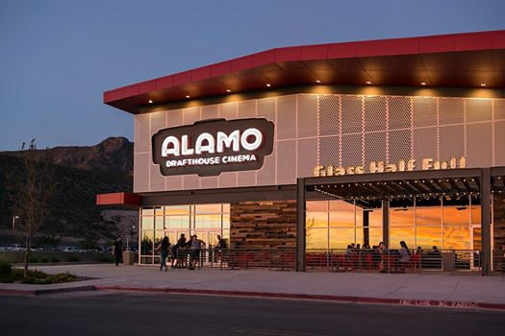
Drag to Reposition

Alamo Drafthouse El Paso

Movie Theater · 39,029 likes
Go to Page
Photos at Alamo Drafthouse El Paso

